MINUTES OF THE ANNUAL GENERAL MEETING

of
LOWER MAINLAND FOOT CARE NURSES ASSOCIATION

(the "Society")

held at Seniors Comeshare 15008 26 Avenue, Surrey, British Columbia,
on the 9th day of December, 2021 at 6:30 p.m.
MEMBERS: | Members in good standing eligible to vote
PRESENT IN PERSON: members in attendance. Quorum has been established.  Attendance taken and by Exported list from LMFNA website documents all members in good standing eligible to vote. | Cathy Wilkins, Diane Hill Doell, Tannis Sorge, Tammy Sheehan, Karen Bellefontaine
PRESENT BY CONFERENCE TELEPHONE: | Susan Fulton, Michelle Warrington
ALSO PRESENT: | Cindy Kainz, Laura Wilson, Pam Maroke, Tash Minwalla, Larissa Shumuk, Magali Krische, Patricia Lluncor, Odette Castillo, Yodit Meheretab
Chair and Secretary of the Meeting
Cath Wilkins acted as Chair of the Meeting and Michelle Warrington acted as Secretary.
Notice of Meeting
The Chair stated that the Secretary had provided proof of e-mail and/or mailing on November 8,2021 of the notice calling the meeting and the other requisite material to all members of record, which was available for inspection upon request. The Association’s Bylaws were posted to the Association website available for all members to access.
Quorum
The Vice President advised that a quorum of members was present in person. The Chair declared the Meeting to be properly constituted for the transaction of business.
Agenda – Upon Motion Duly made, it was resolved that the Agenda be Approved by Diane Hill-Doell and Tash Minwalla
Minutes – Upon Motion Duly made, it was resolved that the Minutes of Dec.15/2020 AGM be approved by Tammy Sheehan and Cath Wilkins
Financial Statements
Diane Hill Doell presented to the meeting the financial statements of the Society for the fiscal year ended December 31st, 2021. Financial statements for the year ended December 31, 2021 handed to all members in good standing in attendance.
UPON MOTION DULY MADE IT WAS RESOLVED that the financial statements of the Society for the fiscal year ended be and are hereby received, approved, ratified and confirmed.
Director's Reports
Presidents Report:
- 2021 was a great year for LMFNA
- We have updated the website – June Spring Fling event was done virtually, reinforces that holding such an event, takes a lot of moving parts with very good value. This is where the members money is going
- Hiring tech support – Ken Monroe – to hold virtual meetings as well as events
- Marketing tool – website, make the directory work for you – your profile is updated, etc
- Last year 113 - 40 new members, now 118 paid members, 29 are new
- Members marketplace – job postings, equipment, need help

Education Report:
- Ideas come from members
- Virtual event and in person
- Online
- Spring event
- 2022 - coming up – alternate online and in person
- Live demos
Treasurer’sReport

Profit Loss Jan – December 2021
- Accurate until end of Nov, estimate for end of Dec
- 6 memberships up for renewal in Dec – income
- Expenses- as per report
- Profit at end of year – preliminary $2091
- Balance sheet – assets and liabilities and equities – Nov.30 - $7731
- Total cash $7418.92
- No acct receivables
- Liabilities – none
- Acts payable – bookkeeping fees, quick books, membership works, ($6990),
- Equities – retained earnings
- Data (history) to do a budget – year 4 now – expecting – membership steady 125,
- Anticipating another conference - ?income from tickets
- Income – $11,200?
- June conference – catering costs $750, honorarium ?$100, Door prizes low at
- Technical support,
- Total expenses - $1100
- Meeting expenses – $1650
- Administration - $6000 – website, legal fees, accounting fees, bank fees, merchant fees, office expenses
- Advertising and promotion – increase website fees to 2700
- Dues and subscriptions – 2022 – Quick books $537, Tannis WebEx – have our own – $250,
- $8632 total expenses
Raising membership fees to $60 annually

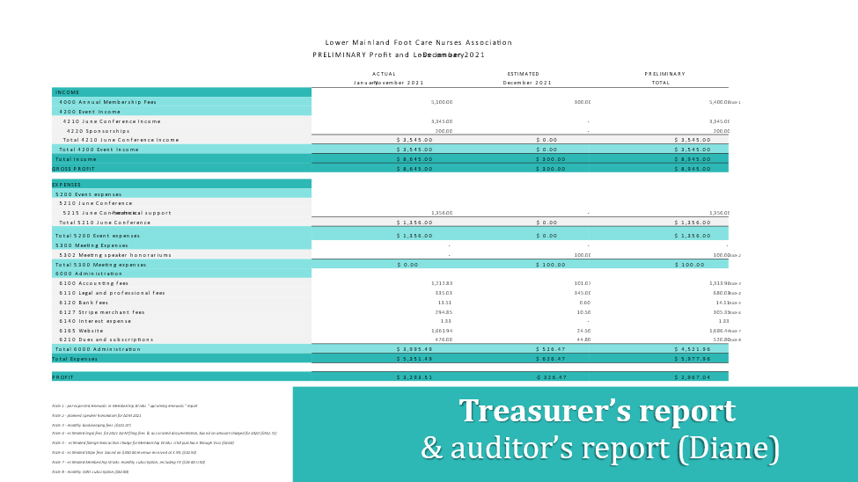
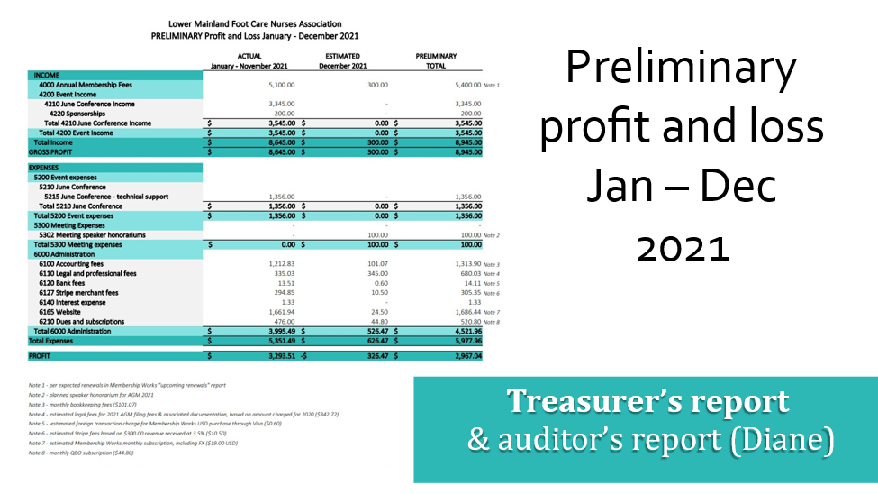

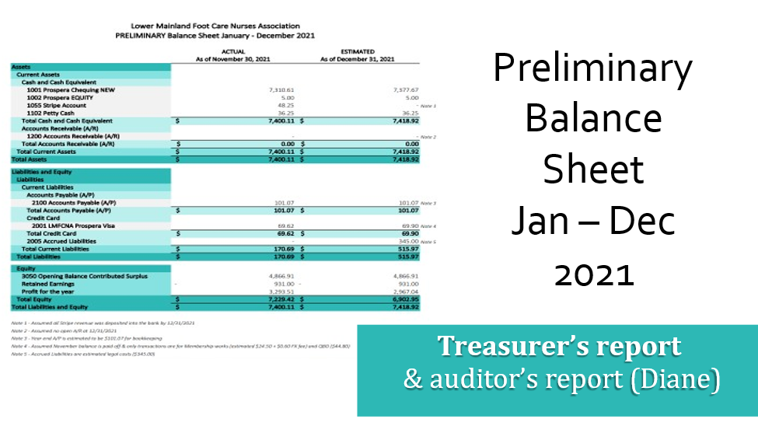
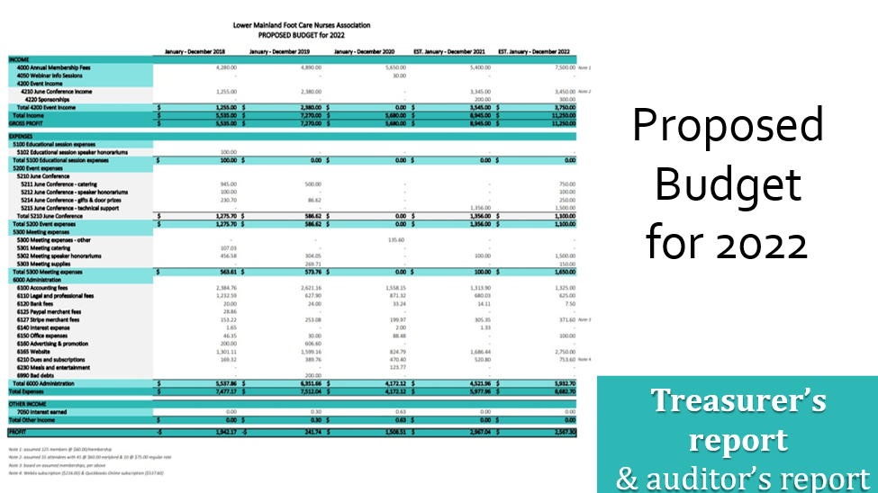
The Chair presented to the meeting the Directors' Report on the activities of the Society during the fiscal year.
New Business
- Change year end to Oct.31 and hold AGM Oct or Nov
- Resolution - Increase membership fees from $50 to $60
- Survey monkey – 100% said they would attend another event – virtual or in person
  - Speakers were rated high from June Spring Fling
  - Event in September instead of Spring or both?
  - Ongoing speakers - different techniques , filing (burrs), offloading, sterilization
  - # of people attended - _+/- 60

UPON MOTION DULY MADE IT WAS RESOLVED that the Director's Report be approved.
Contracts, Acts, Proceedings, Appointments and Payments made by the Directors
The Chair then asked for the approval of all contracts, acts, proceedings, appointments and payments made by the directors of the Society since incorporation.
UPON MOTION DULY MADE IT WAS RESOLVED that all lawful contracts, acts, proceedings, appointments and payments, made by the directors of the Society since incorporation, and which have previously been disclosed to the members, are approved, ratified and confirmed.
Resolution to increase the annual membership dues
The chair asked for the approval from members in good standing to increase the annual LMFNA membership dues from $50 to $60 – an increase of $10. All members in attendance agreed.
UPON MOTION by Cath Wilkins, DULY MADE IT WAS RESOLVED that the annual LMFNA membership dues be increased from $50 to $60 commencing March 1, 2022.
- This will assist to attract more speakers, improve website, cover any losses, hire tech support for virtual meetings – equipment and tech support which we have to contract out.

Election of Directors
The Chair read the names of the current board members and stated that the board members had all agreed to continue to act as directors, except for Julie Phatepekar, who has stepped down as a director and Sylvia Cardin, who is no longer a member. The members elected a new Member-At-Large Director, Cindy Kainz, who would like to assist on committees.
UPON MOTION DULY MADE, IT WAS RESOLVED that the following persons be and are hereby confirmed as directors of the Society to hold office for the coming year or until their successors are elected or appointed, subject to the provisions of the Society’s Bylaws, namely:
Susan Fulton (President) | (Membership Chair) | ________________________
Cathy Wilkins (Vice Pres.) | (Director at Large) | ________________________
Diane Hill Doell (Treasurer)  Michelle Warrington  (Secretary) | ________________________ | ________________________
Tammy Sheehan (Director of Education) | ________________________ | ________________________
Tannis Sorge (Director-At-Large)
Karen Bellefontaine (Director-at-Large)
Pauline Barratt (Director-at-Large)
Cindy Kainz (Director-at-Large)

Other Business
There being no further business, the Meeting was terminated.

Susan Fulton, President
Chair
Michelle Warrington, Secretary

