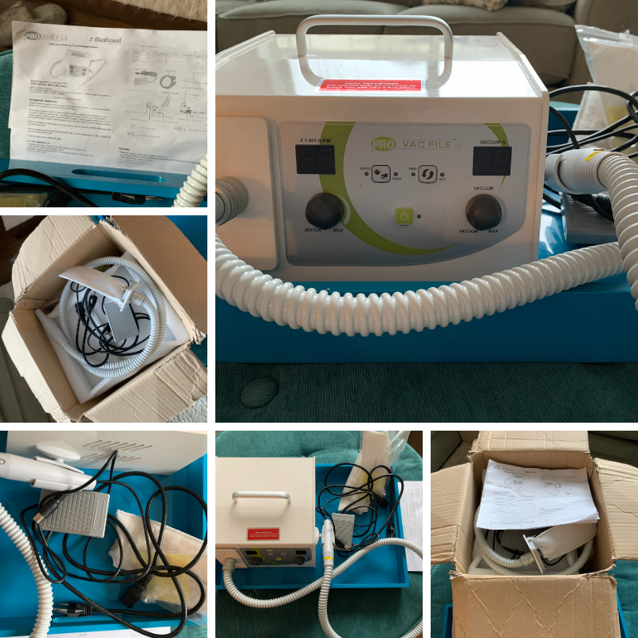

Medicool Podiatry Drill with Integral Vacuum with foot pedal.
Very minimal use.
2 new filter pouches.
Still in box with instructions.
40,000 RPM
Variable speed control
Push/Pull quick lock chuck
Integral vacuum
Lightweight handpiece
Forward/Reverse
Fits all standard burrs
Machine Dimensions: 9” x 10” x 6”
New $1695.00
Asking $1100.00 plus tax
Will bill through Tannis Surge, Peded/Fraser Valley Foot Care
Therefore you will receive an invoice.

Michelle Warrington
604-250-5370
Janet Rosenfeld

