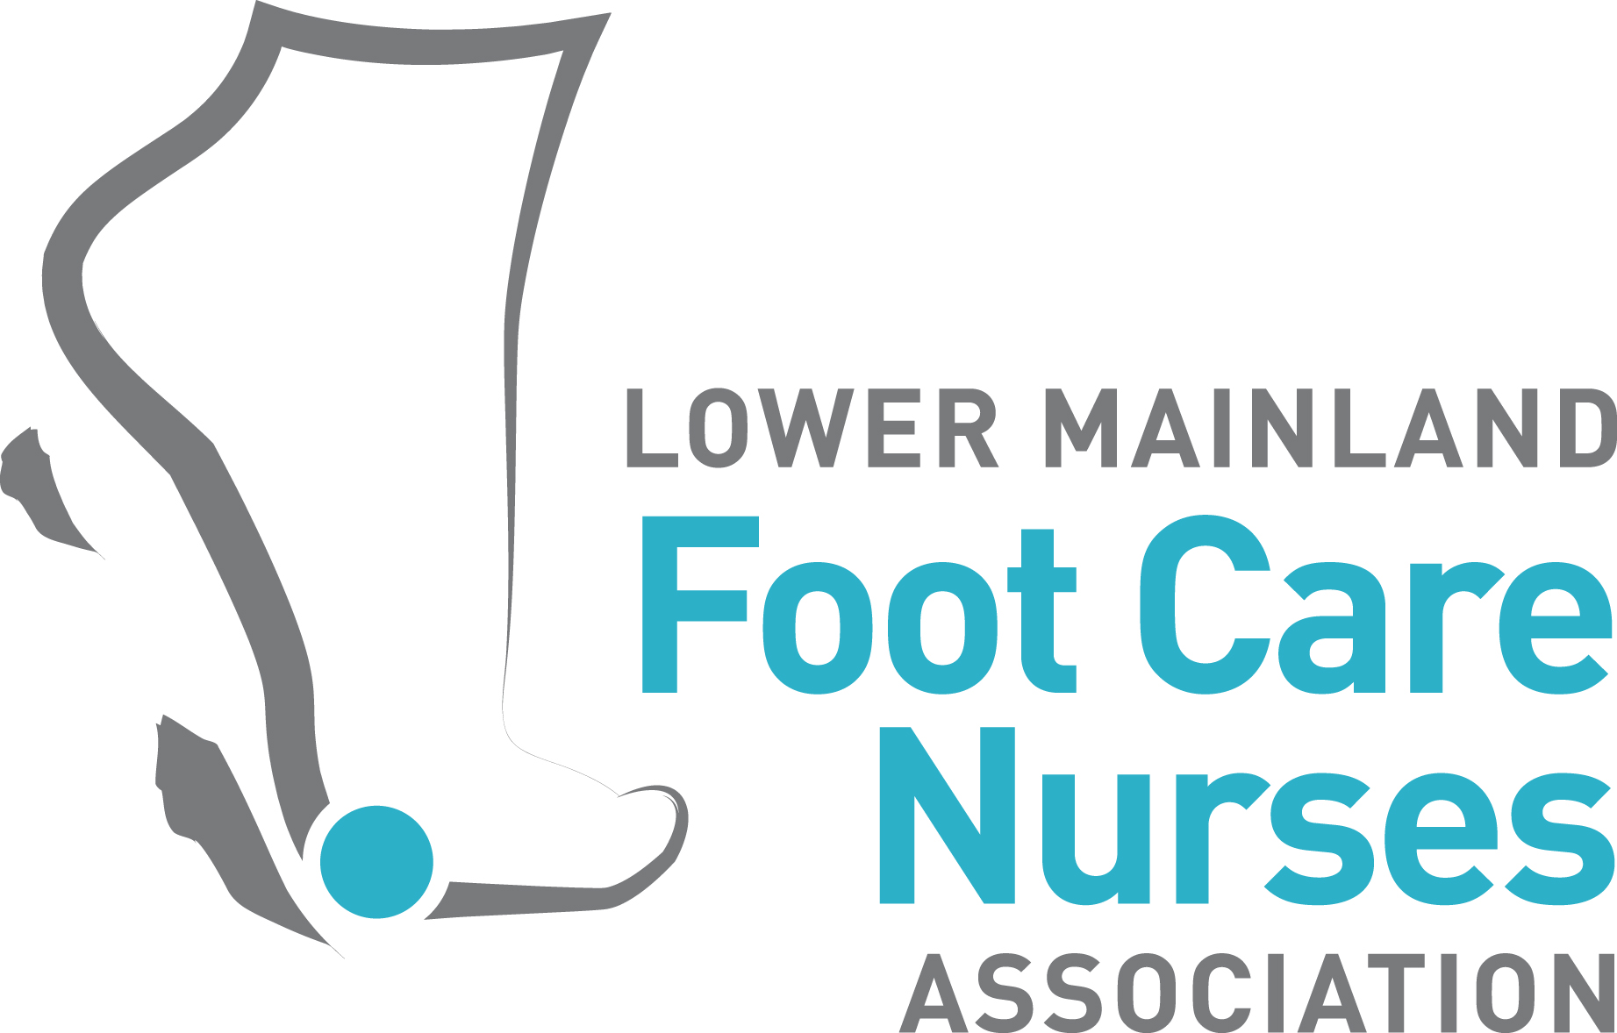 Members Meeting
Date | time 10/23/2019 7:00 PM| Location 15008 26 Avenue Surrey
Meeting called by [Meeting called by]  Type of meeting Members Meeting  Facilitator Cathy Wilkins  Note taker Diane Hill Doell  Timekeeper [Timekeeper] | Attendees [Attendees]  Please read **parking in designated areas only**  Please bring gently worn shoes, socks, personal care items for Nightshift Street Ministries

Agenda Items
Topic | Presenter | Time allotted
 | Kintec Footlab/Pedorthist | Matt Deeter | [Time]
☐ | LMFNA Annual General Meeting Dec 17, 2019 | [Presenter] | [Time]
☐ | Call for Nominations | [Presenter] | [Time]
☐ | Nomination Committee | [Presenter] | [Time]
☐ | Electronic AGM voting | [Presenter] | [Time]
☐ | Live Well with Diabetes Forum Nov 8-10 (Richmond) | [Presenter] | [Time]
☐ | Socks/shoes/personal care items for Nightshift Street Ministries | [Presenter] | [Time]

Highlights
In-depth presentation brought forward by Matt Deeter Kintec White Rock. In attendance where the store managers for Langley & Surrey (sorry their names have been missed here). His presentation demonstrated the collaboration between his specialty & that of foot care nurses and how the two disciplines can work together.

Canadian Certified Pedorthists – C. Ped (C) – are foot orthotic and orthopaedic footwear experts. They are one of the few healthcare professionals trained in the assessment of lower limb anatomy and muscle and joint function.
With specialized education and training in foot orthotics and footwear, Canadian Certified Pedorthists help to alleviate pain, abnormalities and debilitating conditions of the lower limbs and feet. Canadian Certified Pedorthists help patients with a wide range of foot and lower limb problems including:
- Arthritis
- Diabetes
- Plantar fasciitis
- Achilles tendonitis
- Bunions and bunionettes
- Shin splints
- Claw toes or hammer toes
- Limb length discrepancies
- Sports injuries
- Metatarsalgia
- Other foot injuries due to accidents
As proud members of patients’ healthcare teams, Canadian Certified Pedorthists work with physicians, nurse practitioners and other healthcare providers (i.e. foot care nurses). The goal of every Canadian Certified Pedorthist is to help patients achieve and maintain proper foot care and lower limb health so they can live healthy, active lives.
Donations to Nightshift Street Ministries were accepted. A good haul for needy of socks, shoes, monies. Good start.
Due to time constraints, other agenda items were not discussed.
- Annual General Meeting is to be held Dec 17th in conjunction with our Christmas potluck.
- Call for nominations to the Board of Directors. If you are interested in standing for election refer to Part 6 of the bylaws attached to this email. This is a great opportunity for any good standing member to further our group as a whole. Those interested may contact Diane Hill Doell for further details and or state your intent.
- Nomination committee to be established moving forward to 2020 for future board elections.
- Electronic AGM voting. This item to be brought forward to the November meeting for discussion.
- Live Well with Diabetes Forum Nov 8-10 in Richmond.

Next meeting November 19th. Presentation by Route 65 – BC Care Providers Association.
Route 65 is a free service that helps match seniors and their family members with B.C.’s leading operators of independent living, assisted living, long-term care and home support.

